# 

# FACULTY OF EDUCATION

# DEPARTMENT OF EDUCATIONAL FOUNDATIONS EFP 101: FOUNDATIONS OF EDUCATIONAL PSYCOLOGY

DIANA SEJEWE – BIOGRAPHY

201801676

**Bioecological Systems theory**

The bioecological theory of development was formulated by Urie Bronfenbrenner and posits that human development is a transactional process in which individual’s development is influenced by his or her interaction with various aspects and spheres of their environment.

**Microsystem :**According to (Ryan, 2001) Bronfenbrenner explains microsystem as the layer closest to the child and contain the structure with which the child has direct contact. The microsystem encompasses the relationship and interaction a child has with her immediate surroundings, which include school, neighborhood, family and childcare environment.

My name is Diana Sejewe, a 22-year-old girl. I have two siblings, an elder sister and a little sister. I grew up under the strict guidance of my father and mother and they really took good care of me. I had a positive relationship with my parents which helped me grow mentally, emotionally and physically. We usually had quality time with our parents and they instilled discipline and respect in me for example they taught me that all people are the same so I should treat them in the same way which helped me to positively interact well with other students and teachers in school and respected their choices. When solving problems my parent taught me that it was important to solve them as family. My Family was not an extended one that’s why it made it easier for my mother and father to groom us in a way that they see it good, but they allowed us to visit other family members.

According (Enos, 2011) the space you live in and who is around you could affect your behavior, I lived in a village called Charleshilll is located South part of Ghanzi region. Life in my village was awesome and the cost of living is ideally low. Where I live is a really peaceful quiet neighborhood, parents still raise their children the traditional way, every village elder can assume the responsibility of the parent/guardian of the child, for instance, if my neighbor found me doing something wrong they would find ways to correct my behavior as if I’m their own child. This parenting ensured that children grow up well-mannered and responsible, and this is proven by low crime in our area. We used to play together with other children on my neighborhood, after playing we ate at whoever’s home we are in, this showed me the value of sharing because some households were maintained at a very low budget, at times the food was insufficient but they always made sure they share the little they have.

School played an important role in my life, I have become a responsible, self-esteemed, respectful young lady and now I can solve certain life problems on my own. I started my primary level in a school called Boipelo Primary School, we were not many in school due to the population in my village each class had roughly 20 pupils. Teacher were able to monitor our academics and how we behaved in school .When I started my primary school level, I was not a brilliant student but teacher helped me to maximize my academic potential through revisions, homework and regular academic checkup from my parents. I remember one day my mom praying with me the time I was waiting for my PLSE results and she usually encouraged me to pray before writing any exams for God is able to help and change difficult situation.

**Mesosystem**

The mesosystem encompasses the interaction between the child’s microsystem, such as the interactions between the child’s parents and teachers, or between school peers and sliblings.

My parents were known as loving and friendly in my neighborhood and this made it easy for other kids to get used to them, they were not afraid to ask or tell them when they needed something. Playing with other kids on my neighborhood was not a big deal to my parent because they even bought toys for us and other kids to play with. During school vacation my parent always asked for permission from my friends’ parent so that we can go together.

My parents were very concern about my schoolwork, they made sure that when I have some homework is done on time and they usually signed it after. They visited my school frequently for academic check up to ensure that I performed well on my academics. The elderly in our village believed in the importance of education, they hired a school bus that was transporting us to and from school. After school we usually went for revision, they were nonprofit making organization that were formed by parent in my neighborhood where student will go there for free tuition.

**Exosystem**; Is the third level of Bronfenbrenner’s ecological system theory which contains the settings or events that the child does not actively participate in but that have a profound effect on the child’s development, nonetheless.

My parents were self-employed, my mother had a tuck shop and my father owed a hardware where they worked hard to provide for us. Their struggle encouraged me to work hard at school and they also made me believe that someone can be his/her own boss that’s why choose entrepreneurship course because I wanted to be my own boss, control my own profits and be able to answer for the loose made in the business.

At the age of 14 I lost my mother, by then I was still doing my Grade 10 (form Three) it was not easy to cope but we fought until we managed. After the death of my mother my dad was really depressed that he started drinking and smoking, we moved to our grandmother who was now taking care of us. We now started living a new life with our grandmother, I remember one day she took us to the farm and it was our first time going there it was a bit awkward but as time went by we got used to. I started learning different things like how to make sour milk, to plough and how to cook traditional food.

**Macrosystem;** (Guy-Evans, 2020)explains macrosystem as a component of Bronfenbrenner’s ecological system that focus on how cultural elements affect a child’s development such as socioeconomic status, wealth, poverty and ethnicity.

I was born in 1999 by then the President of Botswana was Dr Festus Gontebanye Mogae who served as the President of Botswana from 1998-2008, he stepped down after 10 years and was succeeded by Lieutenant General Ian Khama, served from 2008-2018 and he handed to Mokgweetsi E. K. Masisi who is now ruling the republic of Botswana.

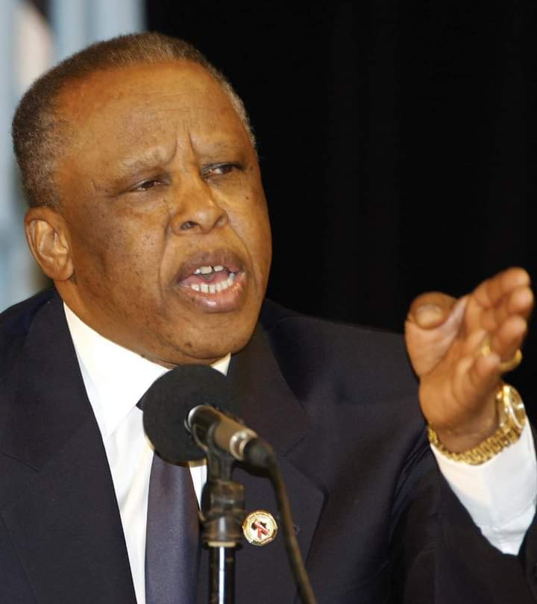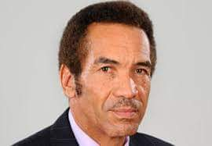 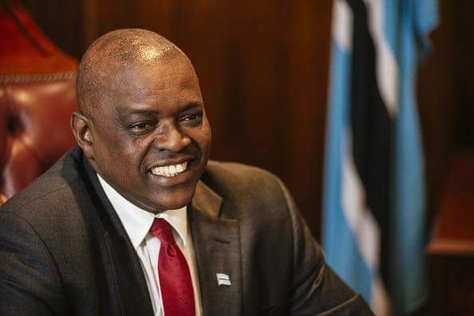

In my home village there’s a combination of different tribes, it consists of Basarwa, Baharero, Bakgalagadi, Afrikaans and Bakgotu. My father is a moherero, my mother was born mokgalagadi. I had the pleasure of experiencing both cultures growing up, I learnt both languages and their culture. Sometimes there was a clash between the two cultures because you will find that what is allowed in sekgalagadi is not allowed in seherero for example during prayers the Kgalagadi believe that men should take off their hut but in seherero a man should not take off his hut at any time.

**Chronosystem**

According to (Guy-Evans, 2020) chronosystem is the fifth and final level of Bronfenbrenner’s ecological system , it consists of all of the environmental changes that occur over lifetime which influence development, including major life transitions, and historical events.

In the year 2011 there was strike in Botswana where workers were refusing to attend work because they demanded 16% increasement of salary, most of teachers were always absent from school because they were marching around the village. There was no one to teach us at school, I even failed my other two subjects which I wrote them again.

My fashion is influenced by Maria Nepembe a young lady from Namibia, she is a modeler, fashion designer, she owns her own business and she is a director, I have always loved her fashion sense and I felt like we looked alike and had same body shape. I never loved reading novels but after following her I now love reading novels, a day can not pass by without reading a novel.

I grew up in a Christian family, every Sundays we go to church and we always pray as a family, share the word together. My parent always encouraged me not to get into any relationship as for now I’m not in any relationship.

References

Enos, R. (2011, May 8). The influence of neighbor.

Guy-Evans, O. (2020, November 09). Bronfenbrenners Ecological System theory.

Ryan, J. (2001, 12 7). Bronfenbrenner's Ecological System Theory .